Ex:1(a) **STUDENT MARK ANALYSIS**

Date: 21/11/22

**AIM**

Analyzing the marks of students using algorithms and flowchart.

**ALGORITHM**

**Step 1**: Start

**Step 2:** Enter the number of students,

**Step 3:** i=0,i<n. If condition is true go to Step 4 or else go to Step 12.

**Step 4**: Read the marks of the students.

**Step 5**: Finding the total marks.

**Step 6**: Finding the average marks.

**Step 7**: Checking for condition average > 80 & average < 100.

**7.1**: If true Grade A is printed, proceed to Step 11.

**Step 8:** Checking for condition average > 60 &

average < 80.

**8.1:** If true Grade B is printed, proceed to Step 11.

**Step 9:** Checking for condition average > 50 &

average < 60.

**9.1:** If true Grade C is printed, proceed to Step 11.

**Step 10:** Checking for condition average < 40.

**10.1:** If true Grade D is printed, proceed to Step 11.

**Step 11:** i=i+1

**Step 12**: Stop

**PSEUDO CODE**

START

READ marks of student

CALCULATE total

CALCULATE average

IF 100>=avg>=80 if true ->PRINT grade A

ELSE 80>=avg>=60 if true ->PRINT grade B

ELSE 60>=avg>=50 if true ->PRINT grade C

ELSE avg<40 if true-> PRINT grade D

END IF

DISPLAY the final result

STOP

**RESULT**

The given problem is solved using flowchart and algorithm.

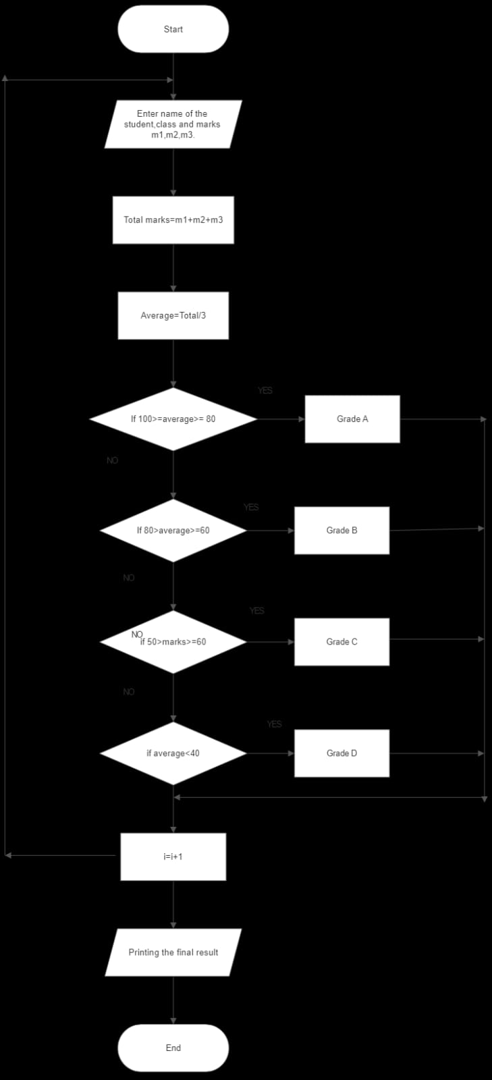**FLOWCHART**

Ex: 1(b) **ELECTRICITY BILLING**

Date: 21/11/22

**AIM**

To calculate electricity billing using flowchart and algorithm.

**ALGORITHM**

**Step 1:** Start

**Step 2:** Get the current unit(CU).

**Step 3:** Get the previous unit(PU).

**Step 4:** Calculate units consumed, N=CU-PU.

**Step 5:** Check for the condition N<=100 if True,

**5.1:** No charges to pay.

**5.2:** Display the amount to pay and go to stop.

**Step 6:** Check for the condition N<=200 if True,

**6.1:** Calculate E.C. formula. FC=20, DC=18, EC=(N-100)*1.5

**6.2:** Calculate the total charges = FC+DC+EC.

**6.3:** Display the amount to pay and go to stop.

**Step 7:** Check for the condition N<=500 if True,

**7.1:** Calculate E.C. formula. FC=30, DC=48, EC=(100*2)+(N-200)*3.5

**7.2:** Calculate the total charges = FC+DC+EC.

**7.3:** Display the amount to pay and go to stop.

**Step 8:** Check for the condition N>500 if True,

**8.1:** Calculate E.C. formula. FC=75, DC=100, EC=(100*3.5)+(300*4.6)+(N-500)*6

**8.2:** Calculate the total charges = FC+DC+EC.

**8.3:** Display the amount to pay and go to stop.

**Step 9:** Stop

**PSEUDO CODE**

START

READ the units consumed

IF N<=100

DISPLAY no charges to pay

ELSE N<=200

COMPUTE EC=(N-100)*1.5

ELSE N<=500

COMPUTE EC=(100*2)+(N-200)*3.5

ELSE N<=500

COMPUTE EC=(100*2)+(N-200)*3.5

ELSE N>500

COMPUTE EC=(100*3.5)+(300*4.6)+(N-500)*6

END IF

COMPUTE total charges=EC+DC+FC

DISPLAY the amount to be paid

STOP

**RESULT**

The given problem is solved using algorithm and flowchart.

**FLOWCHART**

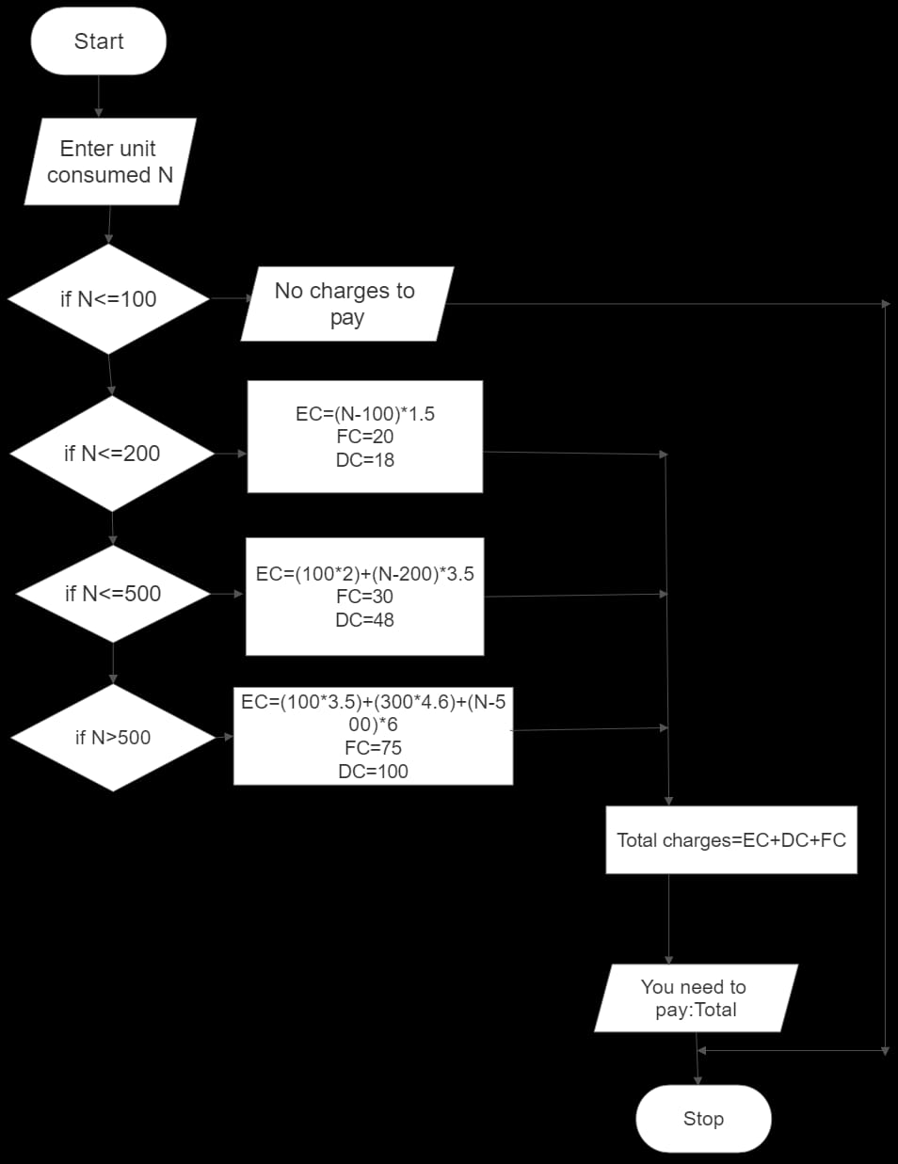

Ex:1(c) **WEIGHT OF STEEL BAR**

Date: 21/11/22

**AIM**

To calculate the weight of a steel bar using algorithm and flowchart.

**ALGORITHM**

**Step 1:** Start

**Step 2:** Enter the diameter of the rod.

**Step 3:** Enter the total number of quantities.

**Step 4:** Weight of a steel bar is calculated using the formula ((d*2)/162.2).

**Step 5:**  Total weight of steel bars are calculated.

**Step 6:** Printing the total weight of the steel bars.

**Step 7:** Stop

**PSEUDO CODE**

START

READ diameter

READ the length

CALCULATE the weight

DISPLAY the total weight

STOP

**RESULT**

The given problem is solved using algorithm and flowchart.

**FLOWCHART**

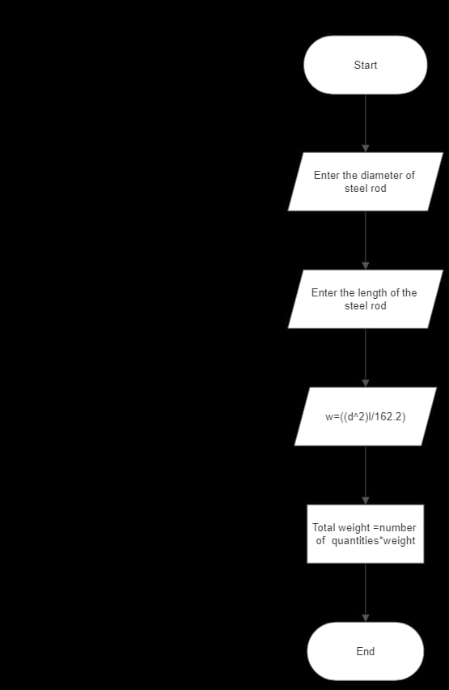

Ex:1(d) **SINE SERIES**

Date: 29/11/22

**AIM**

To find the sine series using flowchart and algorithm.

**ALGORITHM**

**Step 1:** Start

**Step 2:** Initializing i=1.

**Step 3:** Reading the value of x.

**Step 4:** Accepting n value.

**Step 5:** Calculating using the formula x=x*3.14159/180.

**Step 6:** t=x 🡪 assigning value.

**Step 7:** sum=x 🡪assigning the value for sum.

**Step 8:** Checking for the given condition, if true

**8.1:** Sine series is calculated using the given formula t=t*(t-1)*x*x)/(2*i(2*i+1))

**8.2:** sum=sum+t 🡪value for sum is updated.

**8.3:** ‘i’ is incremented by 1

**Step 9:** If condition is false, print sum.

**Step 10:** Stop

**PSEUDO CODE**

START

READ i=1

READ x

READ n

CALCULATE x

IF (i<=n)

CALCULATE t

CALCULATE sum

DISPLAY sine series

STOP

**RESULT**

The given problem is solved by using flowchart and algorithm.

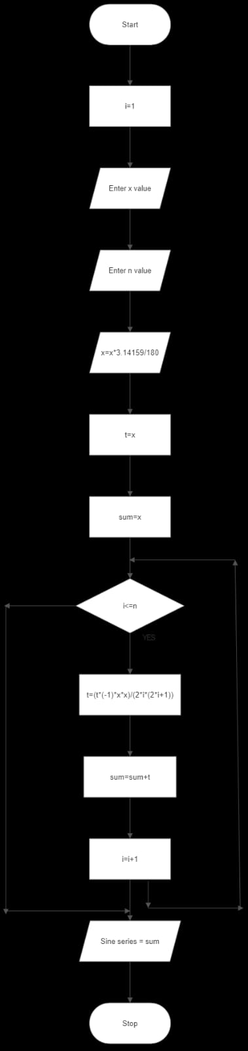

Ex:1(e) **WEIGHT OF MOTORBIKE**

Date: 29/11/22

**AIM**

To calculate the weight of motorbike using algorithm and flowchart.

**ALGORITHM**

**Step 1:** Start

**Step 2:** Enter the weight of frame of the bike.

**Step 3:** Enter the weight of the front wheel.

**Step 4:** Enter the weight of the rear wheel.

**Step 5:** Enter the weight of other components of the bike.

**Step 6:** Printing the total weight of the bike after calculating it. TW=f+W1+W2+C.

**Step 7:** Stop.

**PSEUDO CODE**

START

READ frame

READ front-wheel

READ rear-wheel

READ other components

DISPLAY weight

STOP

**RESULT**

The given problem is solved by using flowchart and algorithm.

**FLOWCHART**

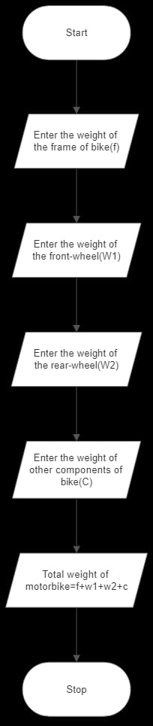

Ex: 1(f) **RETAIL SHOP**

Date: 29/11/22

**AIM**

To calculate the billing process of a retail shop using flowchart and algorithm.

**ALGORITHM**

**Step 1:** Start

**Step 2:** Reading the counter number.

**Step 3:** Enter the total no of items purchased.

**Step 4:** Initializing values for ‘i’, total and subtotal.

**Step 5:** Checking the condition i<n.

**5.1:** If the condition is satisfied, get the product’s name, price, quantity and

discount(if any).

**5.2:** Calculating the subtotal.

**5.3:** Calculating the total.

**5.4:** Increment the value of ’i’ and repeat step 5.

**Step 6:** If the condition is false, get the GST value.

**Step 7:** Calculate the total bill.

**Step 8:** Printing the total bill.

**Step 9:** Stop

**PSUEDO CODE**

START

READ counter number

READ no. of products

READ total,subtotal,i

IF i<n

READ price

CALCULATE subtotal

READ GST

CALCULATE total bill

DISPLAY total bill

STOP

**RESULT**

The given problem is solved using algorithm and flowchart.

**FLOWCHART**

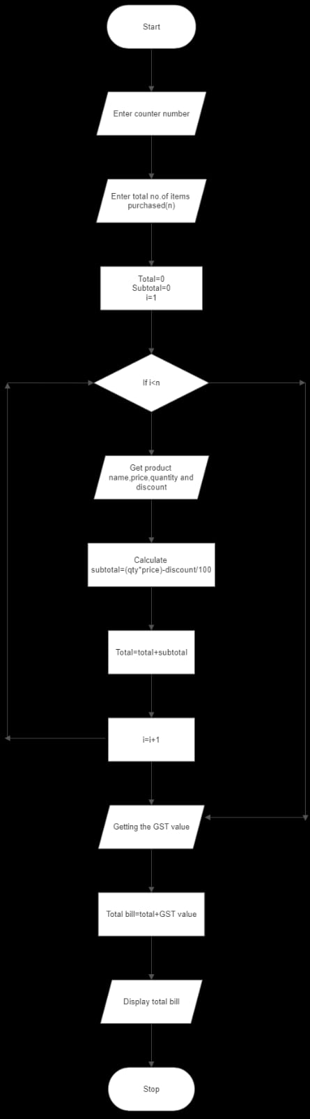

Ex: 1(g) **THREE FACE AC CIRCUIT**

Date: 29/11/22

**AIM**

To calculate electric current in 3 phase AC circuit.

**ALGORITHM**

**Step 1:** Start

**Step 2:** Read the value of Power factor(Pf).

**Step 3:** Read the value of current.

**Step 4:** Read the value of voltage.

**Step 5:** Calculate P using the formula

P=1.732*Pf*I*v.

**Step 6:** Display the value of P.

**Step 7:** Stop

**PSEUDO CODE**

START

READ power factor

READ current

READ voltage

CALCULATE P=1.732*Pf*I*V

DISPLAY P

STOP

**RESULT**

The given problem is solved by using flowchart and algorithm.

**FLOWCHART**

